IAST**How to come to IAST/TSE**

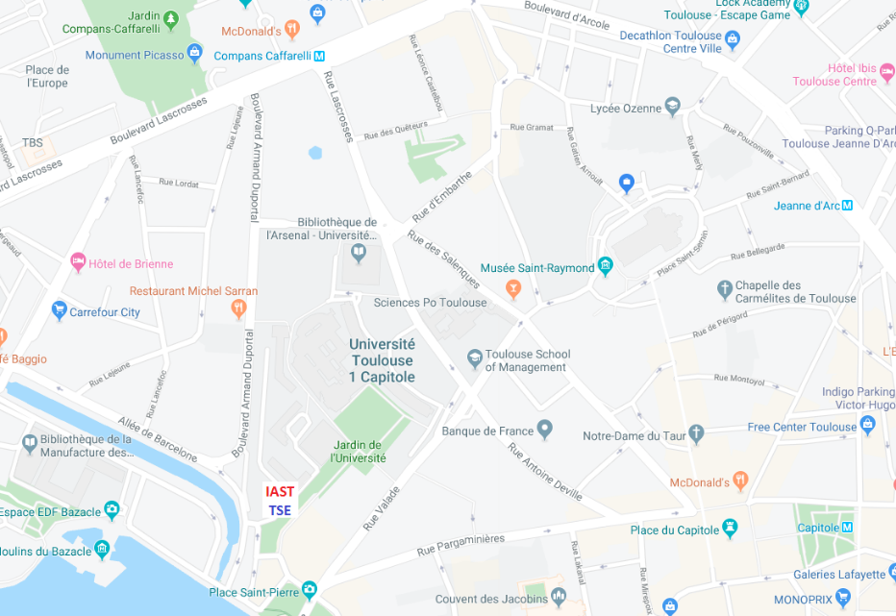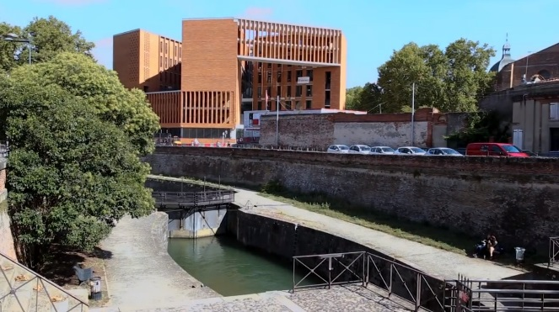

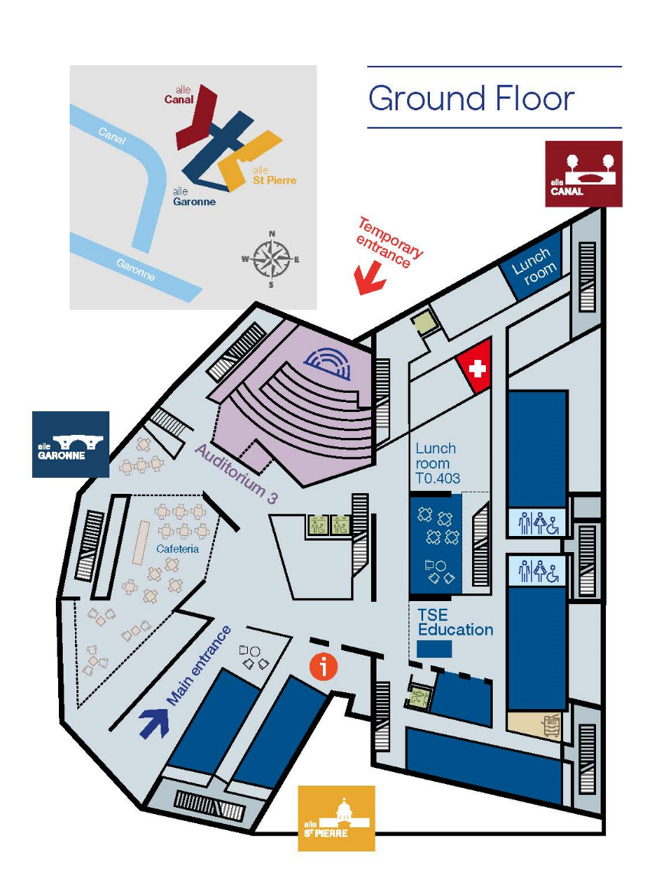

**Reception**

**To enter IAST/TSE Building**

Please enter by the Main Entrance,

1 esplanade de l’Université,

next to Place Saint Pierre.